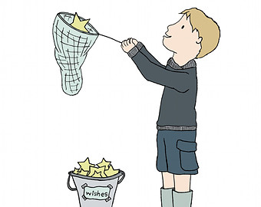
STAR LIGHT,
STAR BRIGHT,
FIRST STAR
I SEE TONIGHT,

I WISH I MAY,
I WISH I MIGHT,
HAVE THE WISH
I WISH TONIGHT.

JUST LIKE ME
Just like “this”
Or just like “that”.
Oh me, oh my, oh dear!

Just like “him”
Or just like “her”.
That is all I hear!

Just like “some”
Or just like “one”.
Who says it has to be?

Just like “you”
Or just like “them”.
Well how ’bout just like ME?

