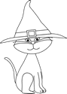
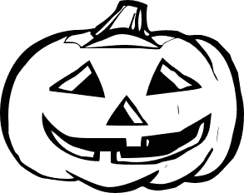
ON HALLOWEEN
On Halloween,
Look at me,
And see the funny things I see.
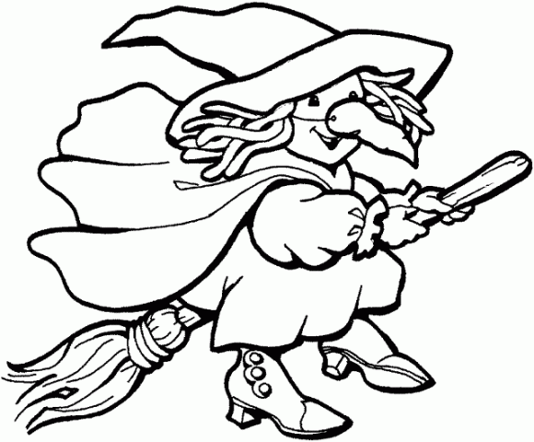
An orange pumpkin,
A black cat,
A green witch,
A scary bat.
On Halloween,
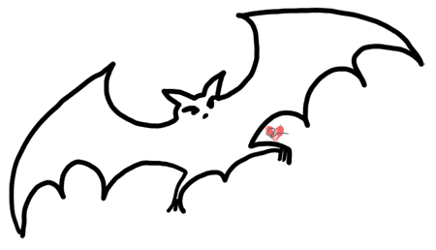
Look at me,
And see the one that I will be.

