Bug and Bee
Once there as a little bug,
Her legs were white and black.
She had two big orange wings,
And a spot upon her back.
She liked to eat the long green grass,
And fly around the trees.
And she was friends with all she met,
Except the yellow bees.
But one day as she flew around,
She saw a small bee crying.
She sat down next to him and said,
“I’ll help you with your flying!”
Pretty soon, bee was up in flight
Saying, “Thank you little one!”
From that day on, they were best of friends,
Always having fun.

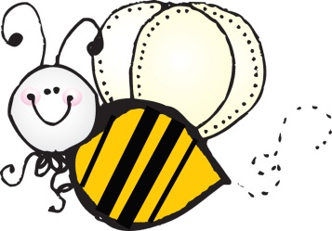

SPRING
When its springtime and it’s windy,
Then a kite I like to fly.
When it rains on my umbrella,
See a rainbow in the sky.
Oh, it’s springtime,
Oh, it’s springtime,
When the rain makes flowers grow.
Say hello to pretty sunshine,
Say goodbye to melting snow.

