It’s Earth Day
Grab a shovel,
Pull on gloves,
Come outside with me.
Pick up papers,
Cans and cups
And other trash you see.
Rake the grass
Or scratch the soil.
Plant a little tree.
Every effort makes our eath
A brighter place to be.
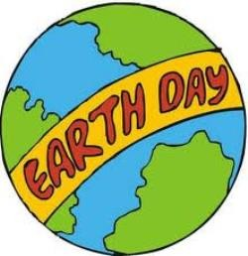

OUR WORLD

The grass is green,
The sky is blue,
The moon is white,
The clouds are, too.
The sun is yellow,
The trees are brown,
The leaves are red
When falling down.
The sunset’s orange,
The air is clear,
What a colorful world
We have right here!

In the Earth

On the earth,
What do you see?
Grass and trees
And the deep blue sea,
In the earth,
What do you see?
Metal and rock
As hot as can be!

